9/4 topic

Ohm’s Law

V = IR but we cannot say R 取決於 V 和 I

R = 材質的電阻程度 \* 長度/截面積

Engineering is the porpose of science

9/8 topic

Computing in terms of signal transformation

computing is a transformation of a signal, a example of computing

V2 = f(V1) , It may be complex and easy in different ways. V1 may be a complex command or syntax or message, output may be something like information.

Simple example if the computing command is f(x) = x + 1 , then V2 = V1 + 1

however, it is a sample example.

Motivating Example ‘

We learned something like transformer (電壓器) in high school , think about the following example

Before we design the structure , why we care about the voltage so much.

Answer : because the voltage is the carrier of the signal in computing.

Think about how we use voltage to control those binary information , since the digital world is all by 0 and 1.

電壓 is a analog signal.

how to transform analog signal to digital signal.

Answer : 離散化 discretization

therefore, the following picture is a digital signal of 110001111

and all the blue line which separate the signal is called sampling.

We make the voltage of the input higher than the threshold, then we can create and send a 1 digital signal. On the other hand, if we make the voltage of the input lower than the threshold, then we create and send a 0 digital signal.

What if the voltage of the input as high as the threshold, the bad news is this kind of simple design cannot deal with it, the good news is that we will talk about another way to handle it in next couple of weeks.

* Threshold sometimes are multiple , not only one threshold in the same time.

We agree that it is simple of voltage signal to digital signal, but how do we control or create the exact voltage we want.

Resistor as a tool for translation

If the original was the picture on the top, we can actually turn it into the picture in the buttom.

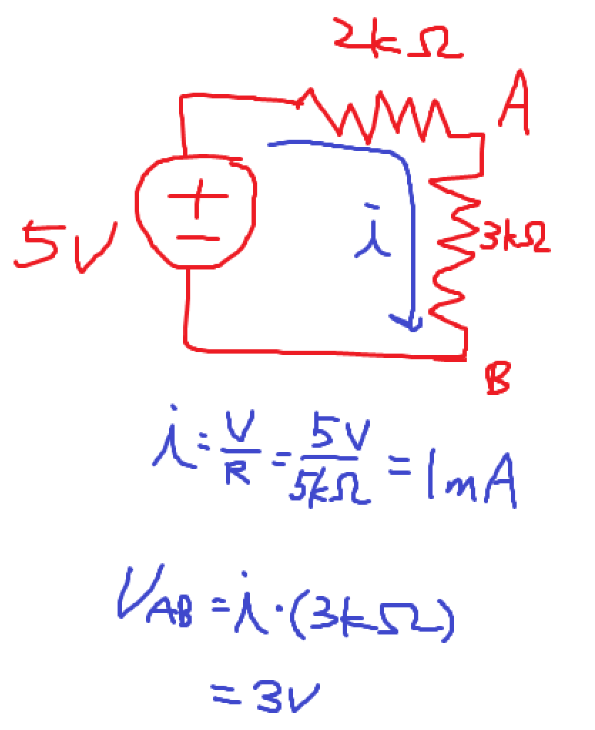

Circuit terminology

Terminology

Circuit 電路

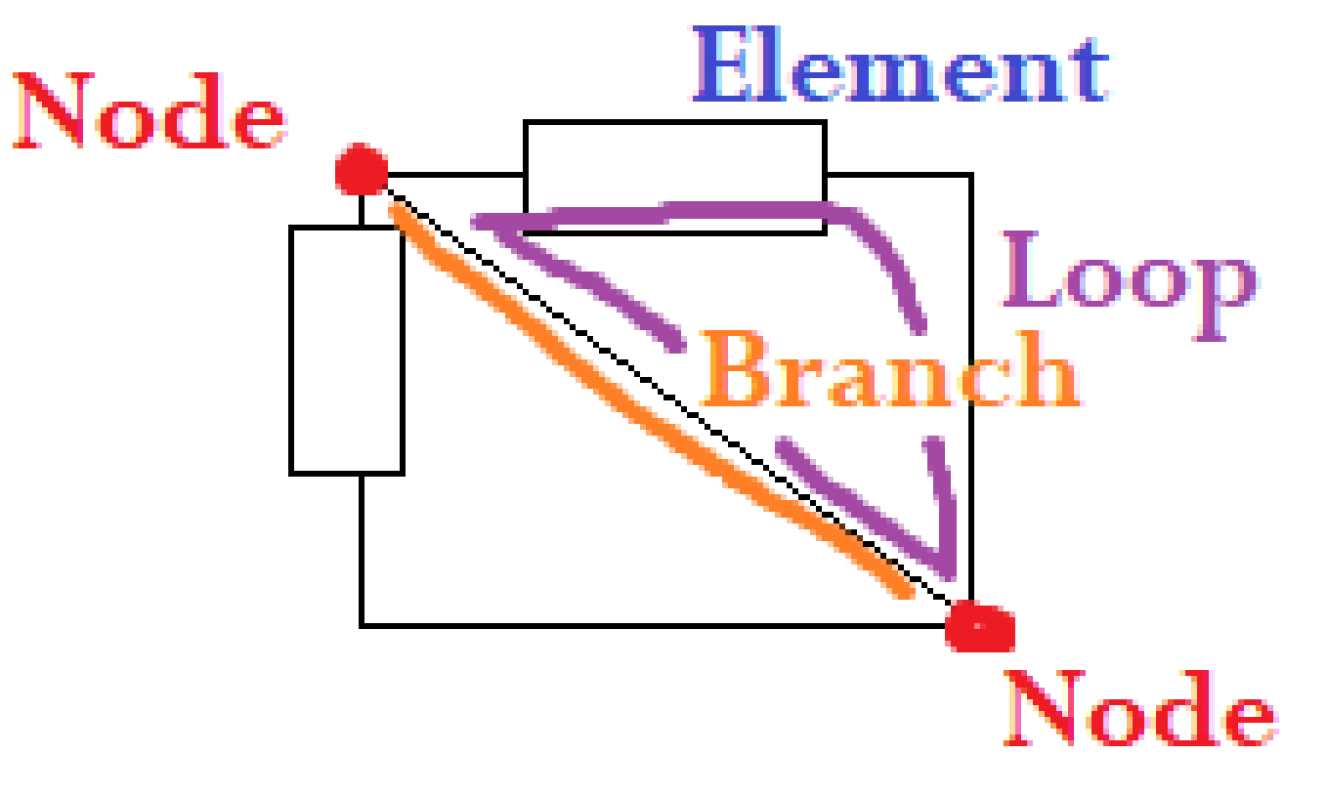

A Brance is between two nodes.

All of the resister , something function called element.

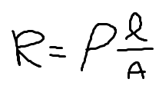

R = 電阻值

長得像P不是P的 = 材質的電阻係數

L = 長度

A = 截面積



Resister

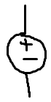

Ideal Voltage Source

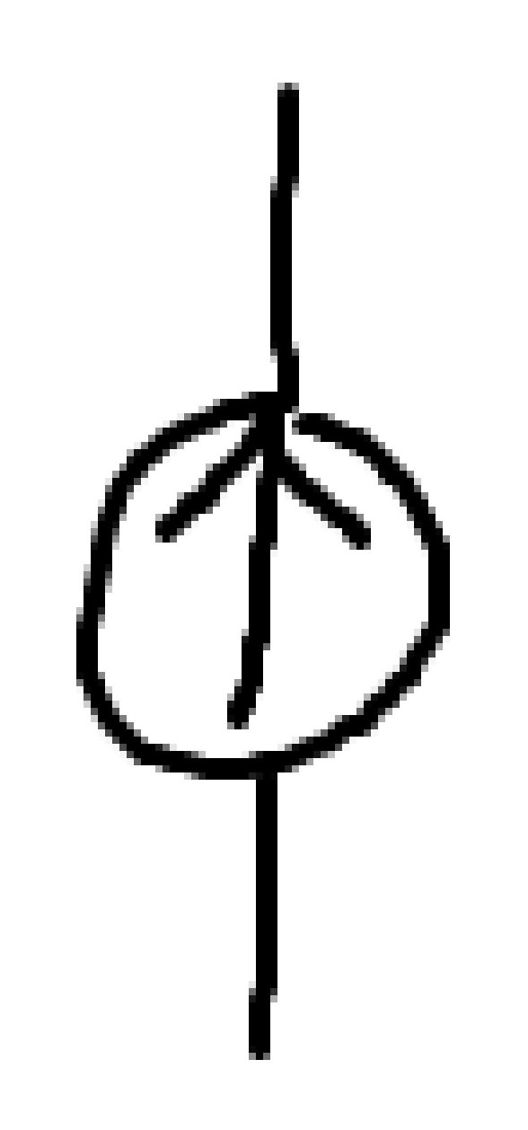

Ideal current source

i-v characteristics

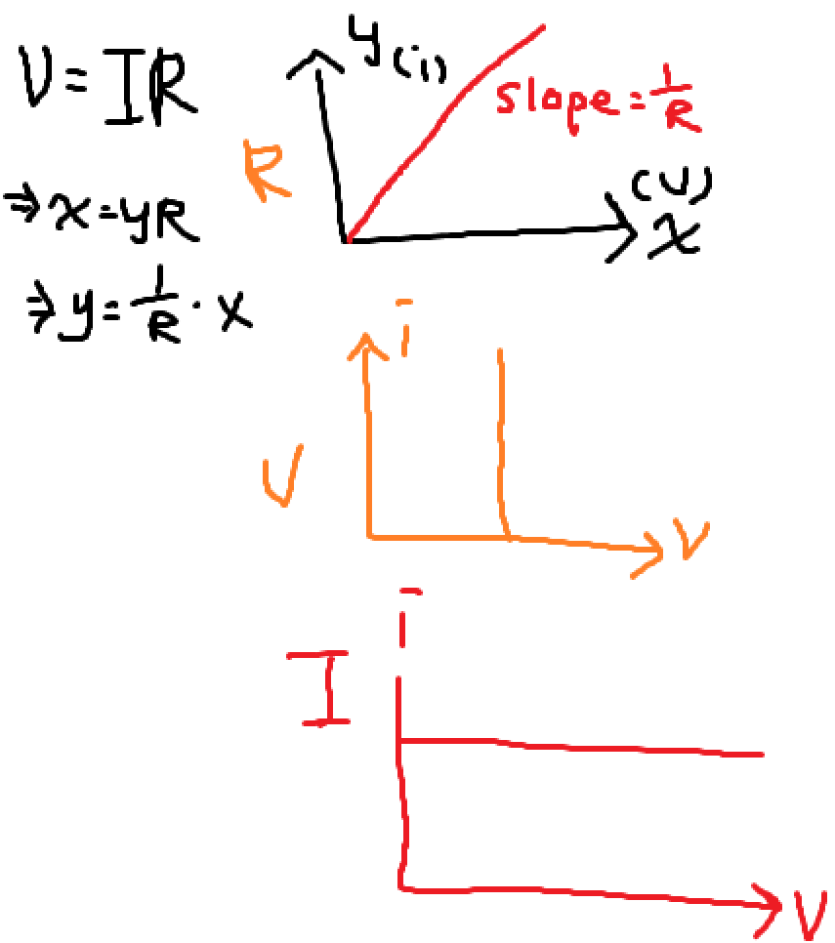

Kirchloff’s Law -> KCL and KVL

克希荷夫電路定律

LMD : 不考慮元件中的構造

KCL :

所有進入節點的電流要等於所有離開節點的電流

branch current = current flowing in the branch

KVL:

Sum of the brance voltages around a loop must be zero.

9/11 topic

Topics today

The basic method of circuit analysis

We will gradually learn the way more organized.

One of the method that will guarantee how to measure the voltage or current

We can write a programming ro control or analyze the voltage or current

Today we will also intend the i-v chart

Further analyze the circuit much more efficiently and easily.

Recall is a keyword in the class.

It’s effective to make connection from topics to topics we talked about.

We want to determine value of i2

First we should learn in more general terms. So we can think about this picture after.

When we have k element in our circuit, we will have 2k variable and expression.

We need to know how to use KCL and KVL to know to relations between all of the variables. i – v characteristic can help we a lot in analyzing the circuit.

* Basic Method

1. define branch variables
2. apply element’s law for each element
3. apply KCL and KVL
4. solve the joint equations obtained from 2. and 3.

Topics Today

Applications

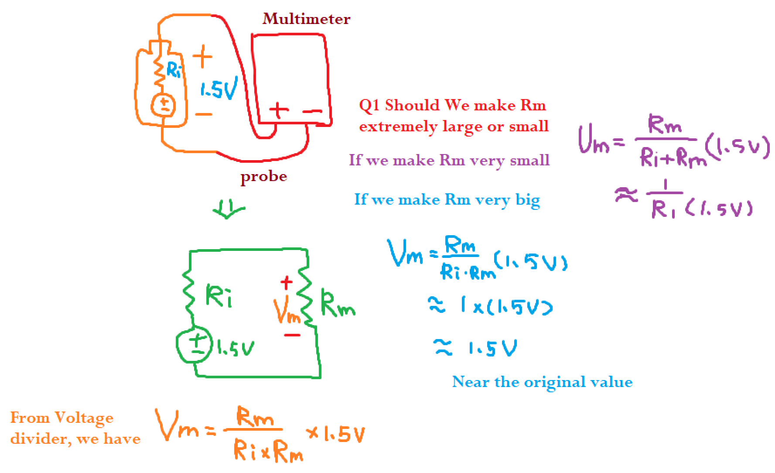

Voltage divider

Current divider

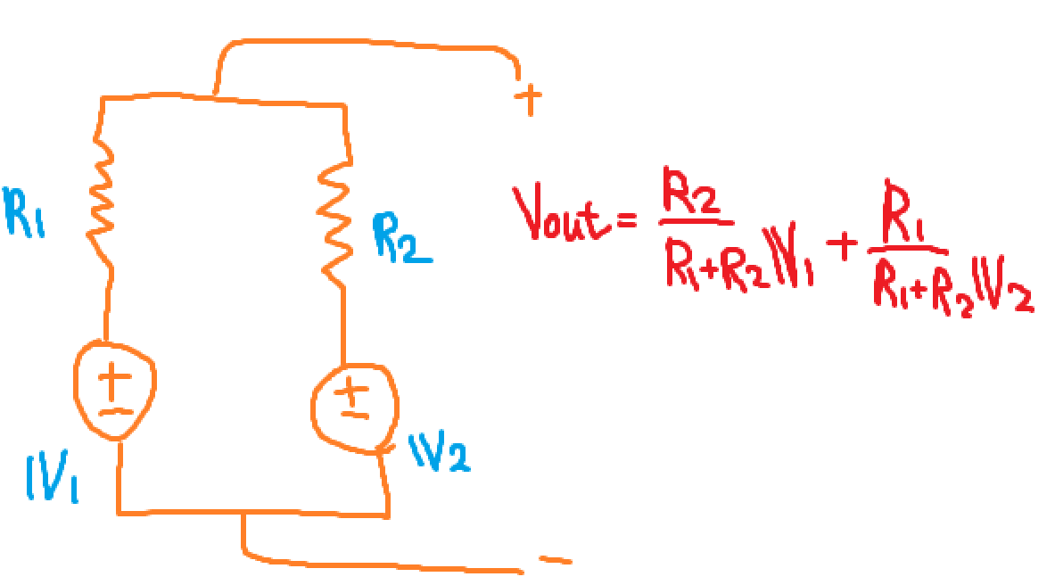

Essentially, every element have their own resistance inside themselves (internal).

Circuit response

Linearity

A function is linear if

1. f(ax) = af(x)
2. f(c+d) = f(c) + f(d)

Nonlinear circuit analysis

Small signal analysis

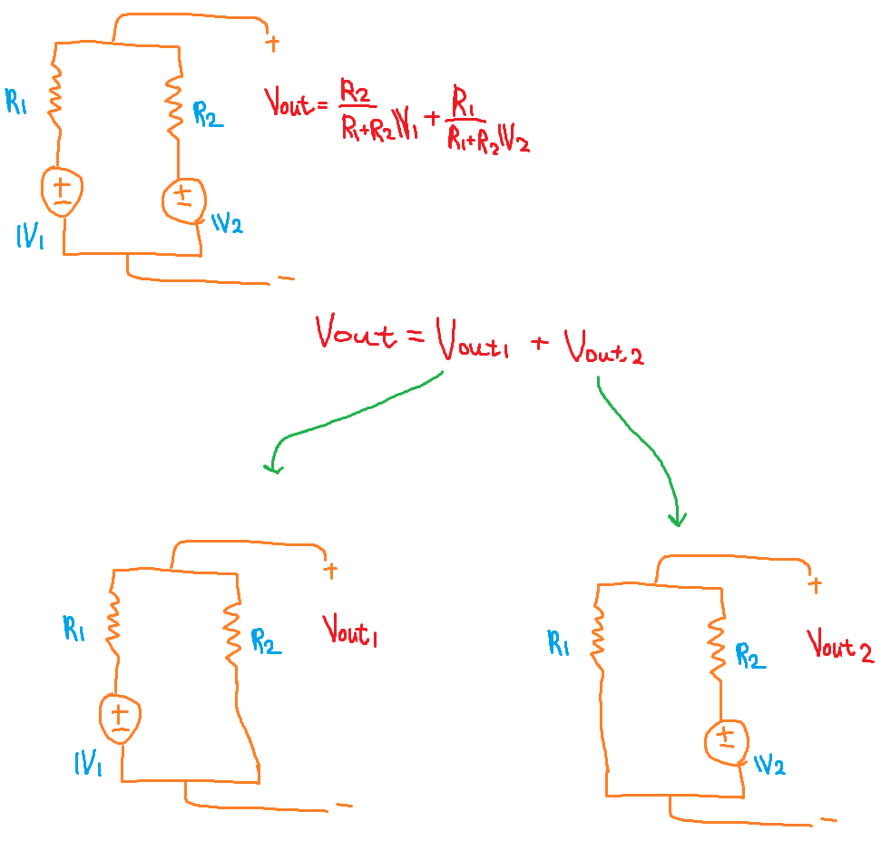

Superposition, Part I

Nonlinear elements

An nonlinear element example – silicon diode

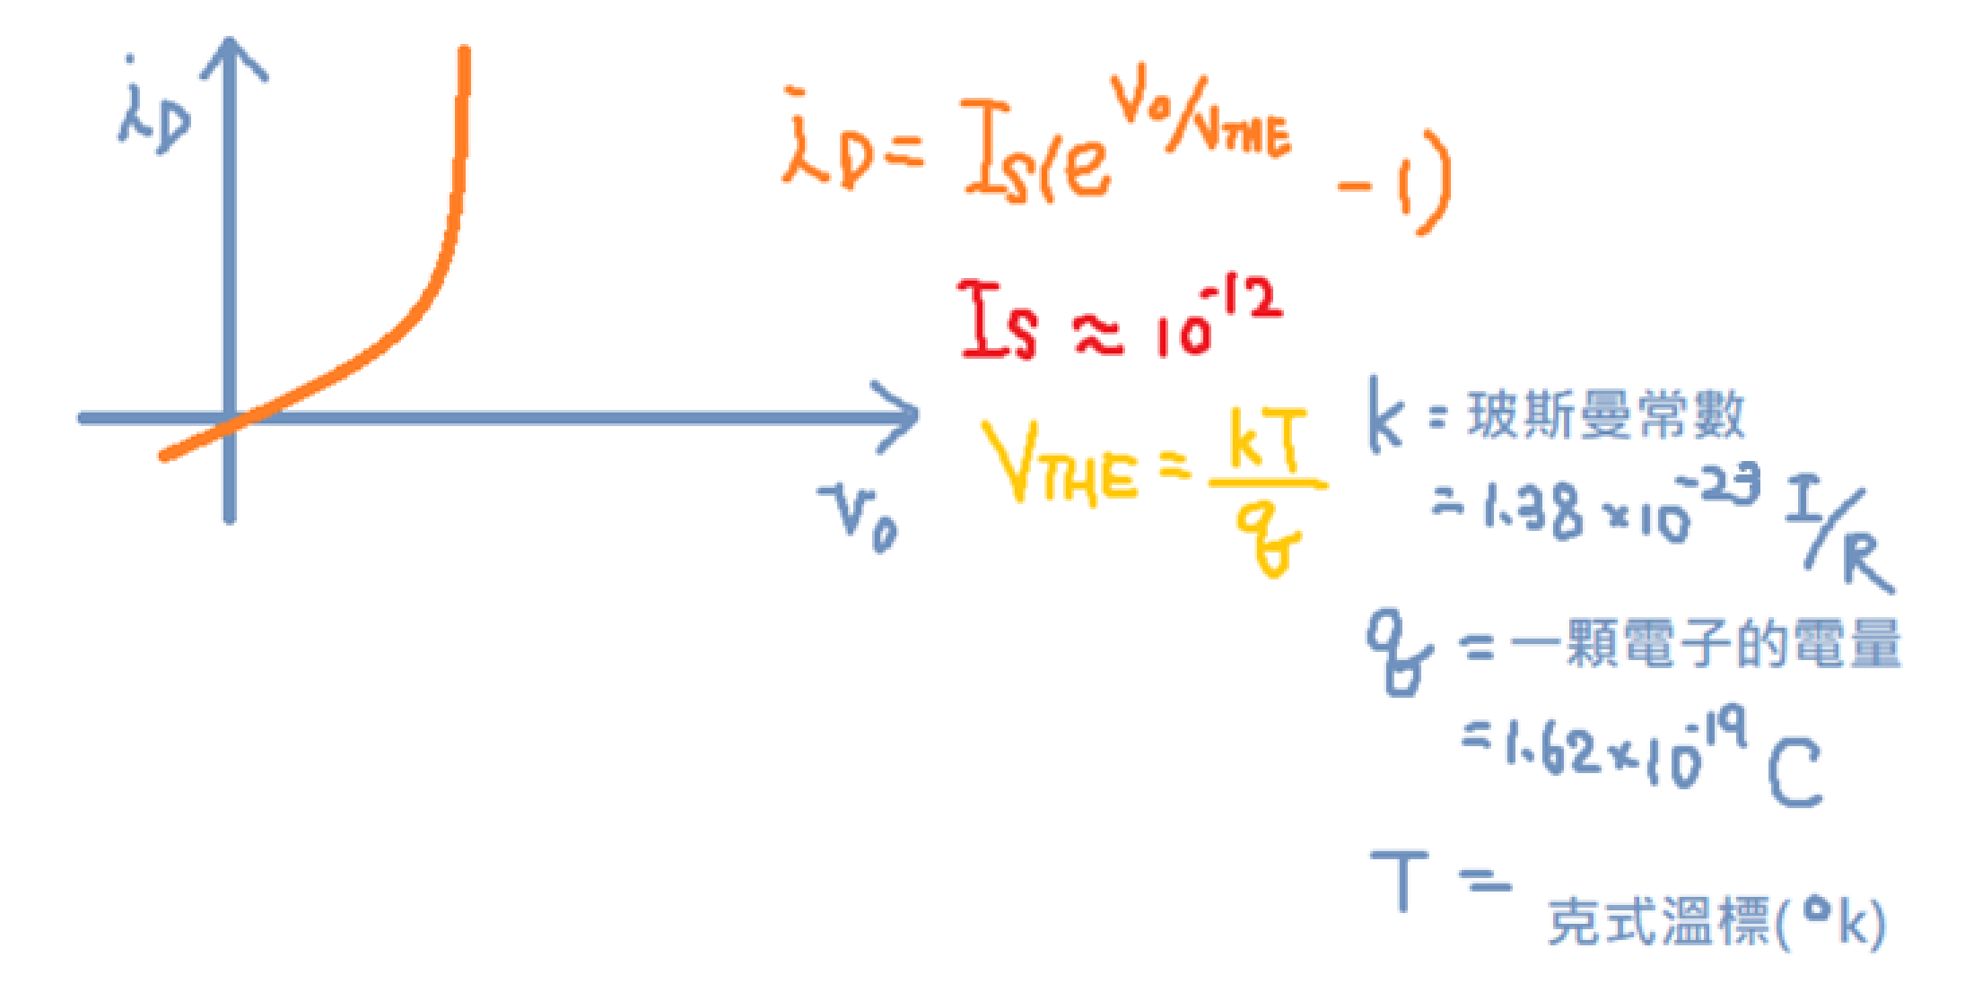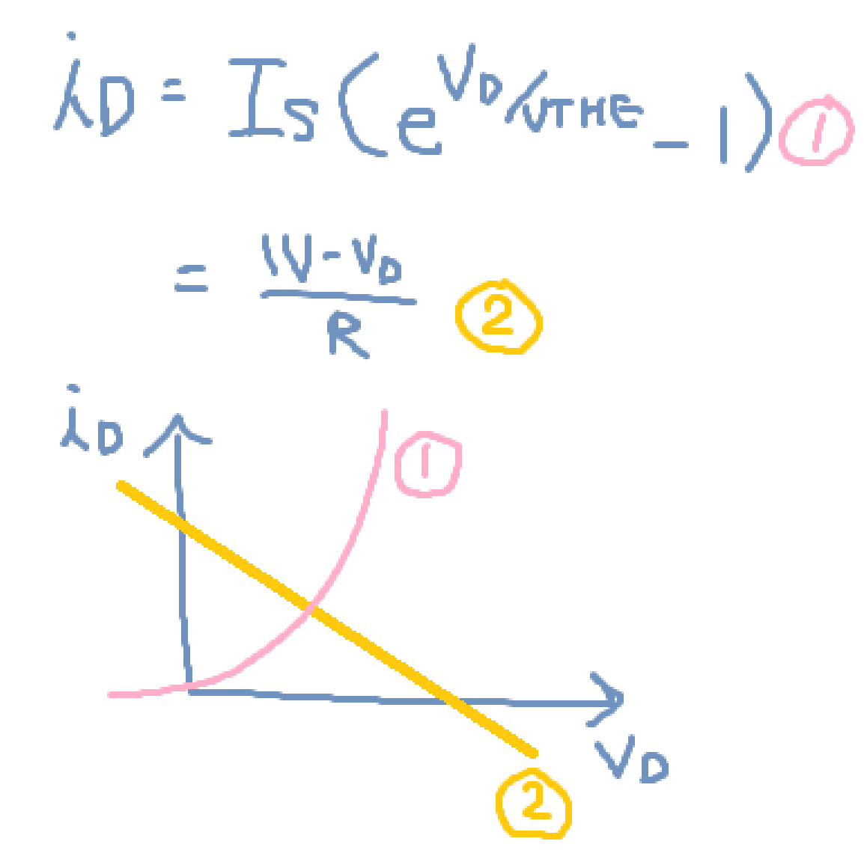

Topics Today

Application:

half-wave rectifier

Piecewise linear analysis

Topics today

Digital abstraction

The static discipline

期末

